Sensitive Species Needs Assessment
Survey Summary
December 2011
Virginia Guhin and Grey Hayes
Elkhorn Slough Coastal Training

The 2011 Sensitive Species survey was conducted from May – August and involved a mailing to over 3,000 from the ESNERR CT contact list. As of October 7, 2011 there were 98 individuals who had visited the survey and responded to some combination of the 4 questions posed.

Question 1, Who are you?

The survey indicated that 43% of the responders were State agency staff, 22% Private consultants. The remaining 35% fell into many other categories with no more than 10% in any one category.

Question 2, Level of interest in training on one of the species listed.

The answers to this question are ranked between: definitely not interested; probably not interested; somewhat interested, and; extremely interested. Answers are ranked for all responses from least interested (0) to ‘extremely interested’ (4). There was variation in the number of respondents (N) for each species.

Here are the responses:
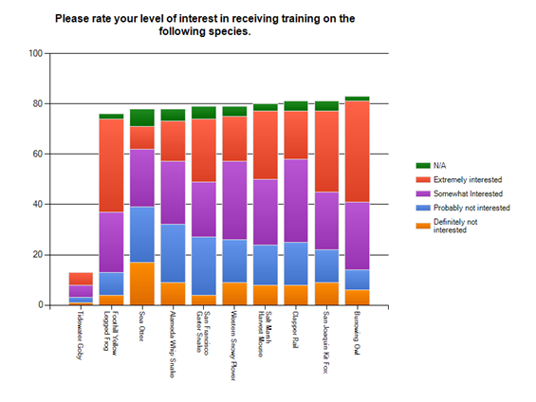

Species | Rank | N
Foothill Yellow Legged Frog | 3.27 | 76
Burrowing Owl | 3.25 | 83
Tidewater Goby | 3.08 | 13
San Joaquin Kit Fox | 3.01 | 81
Salt Marsh Harvest Mouse | 2.94 | 80
San Francisco Garter Snake | 2.92 | 79
Clapper Rail | 2.82 | 81
Western Snowy Plover | 2.77 | 79
Alameda Whip Snake | 2.66 | 78
Sea Otter | 2.34 | 78

We also allowed respondents to suggest species other than those listed above. We received 7 requests for training on Arroyo toad, 4 for steelhead trout, and 4 for listed plants. These are relatively small numbers given the response rate but may indicate species to survey about when assessing future needs.

Question 3, Sensitive species training focus.

Of the 98 responders to the survey only 41 replied with details about what, specifically, they would like for sensitive species workshops to focus on. Respondents emphasized a need to focus trainings on species’ life history, identification, habitat identification, distribution, capture and handling, surveying, management and protection practices.

Question 4, How much can you afford?

There were 84 responses to this question, 43% prefer to spend between $60-$100 and 35% preferring $125-$250. Most stated travel restrictions and budget cuts to their agencies as limiting factors.

Recommendations

There is some interest in most of the species about which we surveyed. The most popular species from the survey is the burrowing owl, which should be the first new sensitive species workshop to be developed based solely on audience interest. From the comments it appears most responders are looking for a general biology of the species workshop with some information on management and protection measures.

It is interesting to note that the majority of the responders were with state agencies and yet this is the group hit hardest by budget restrictions. This is obviously the audience that most needs and wants this sort of training, so budget limitations will be considered when offering any of these workshops. Offering a training costing no more than $150 would best meet audience needs.

